TEAM 15

CHECKER GAME

REGISTER NUMBER : RA2011003010869

THIS PROJECT COMPRESIES MORE LIKE THE CHESSS GAME . IN TERMS OF SOCEITY BENEFITS IT COMBINES OF INTERSET IN PLAYING THE GAME. THIS PROJECT MAINLY POINTS FOR RUKLES AND REGULATION FOR THE PARTICULAR GAME. THAT TEST FOR PEOPLE WHO ARE INTERSET. This is a great way to learn how to make sound judgment calls, which is a skill that can be used in other areas of life. CHECKERS HELPS IN CONCENTRATION SKILLS. IT REGULARLY INCREASES PATIENCE

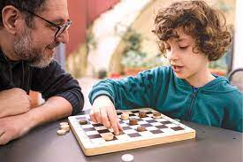

CHECKER GAME IS EASY TO BRING TO THE SOCIETY AS IT EASY FOR TEACHING THE KIDS. AS WE INIDANS SHOULD BE PROUD TO HAVE A GRANDMASTER OF CHESS, WHO BROUGHT LOTS OF GLORY TO OUR COUNTRY , NONE OTHER THAN THE VISWANATH ANAND

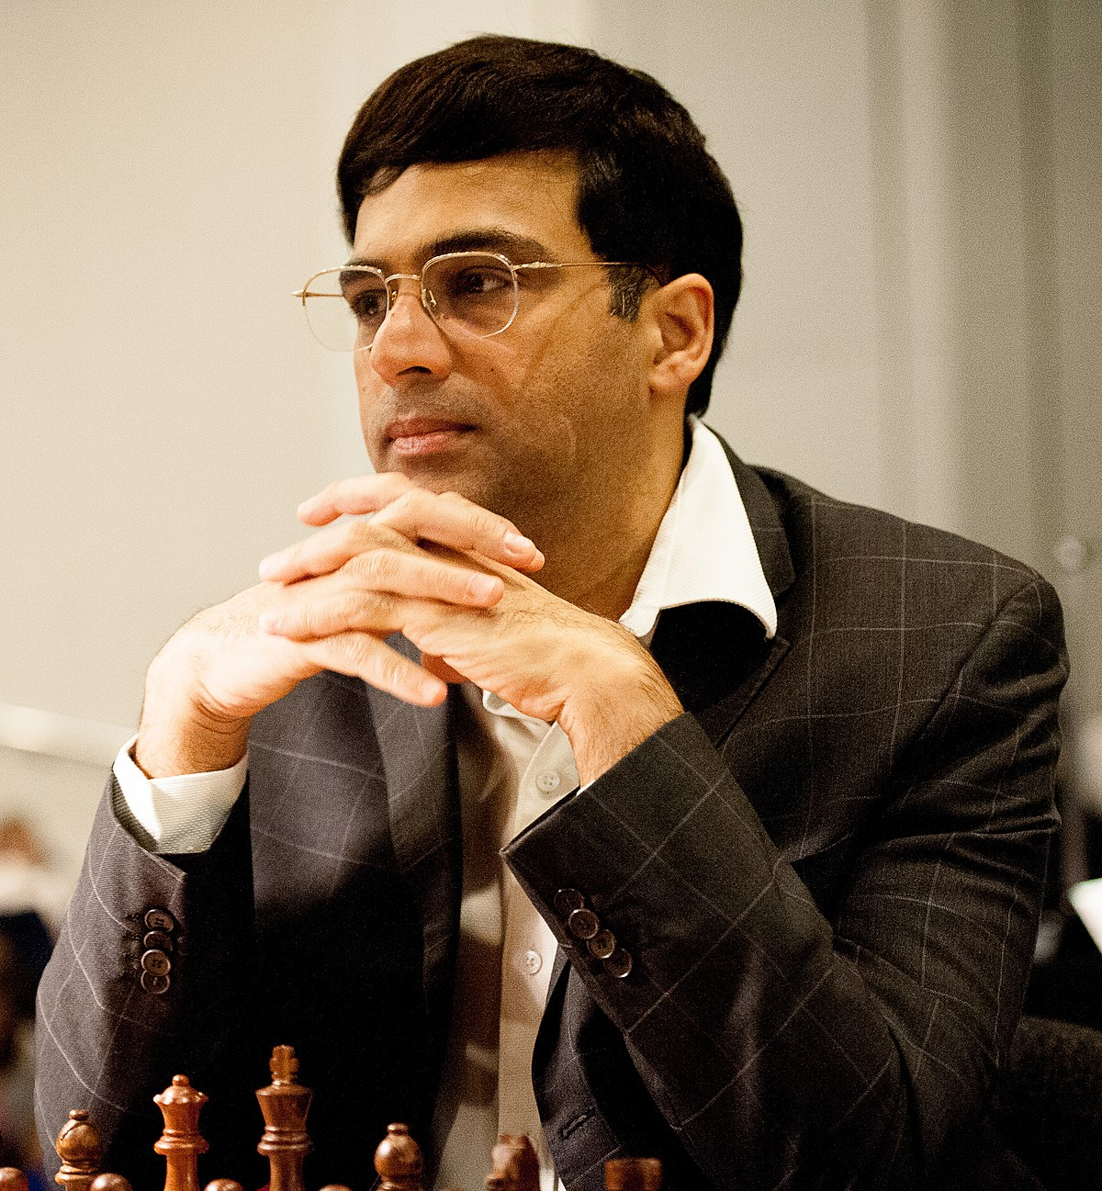

PROBLEM STATEMENT :

This can be explained by the cause that the checkers game requires lots of attention and patience . That is it leads with problem . Thus this game requires lots of hours to finish the game , which ends in hectic situation

Objectives :

This is to be done by the hours of practice , that is by morely which mode of paying attention . The AI code application is done of mainly by the python programming . Thus objective can be applied or done effectively most by uses of practice and paying attention .

